National Technical University of Ukraine “Igor Sikorsky Kyiv Polytechnic Institute”

Coursework

from a discipline

“Visualization of graphical and geometric information”

Performed by:

Bohdan Kalika

TM-01mp

Reviewed by:

Anatol Demchyshyn

Kyiv – 2020

In this course work I have made tangent and a normal vector to the graphical figure “Snail surface”. The surface looks like:

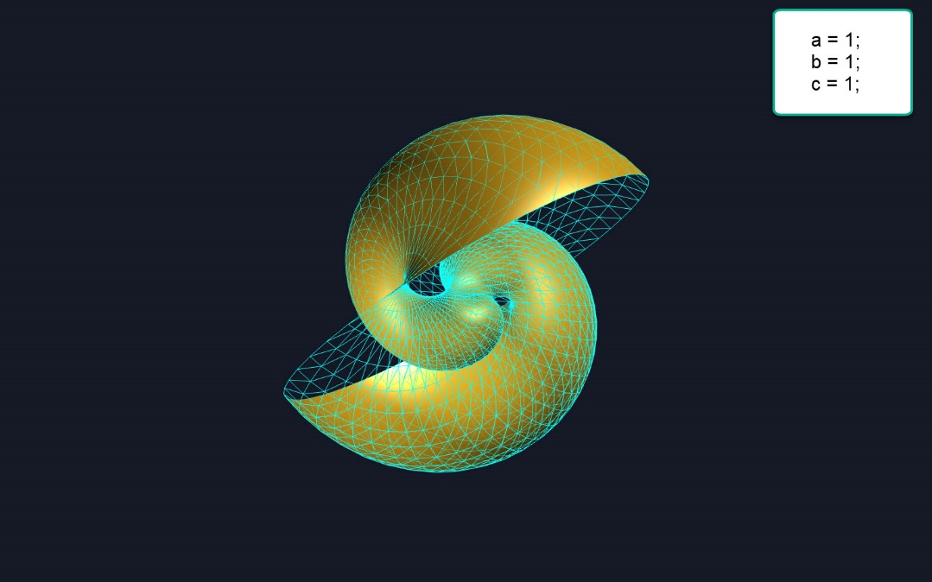

To create this surface, need to use a formula [1]:

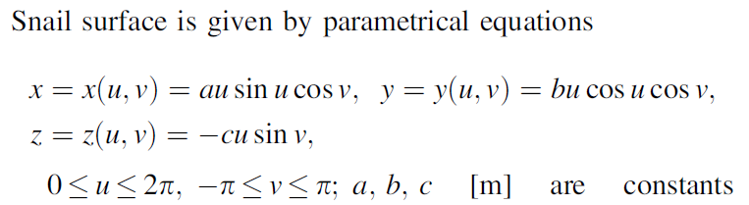

For implementing this formula in a programing language, I choose to code it by the JavaScript and for visualize as a surface I used a THREEEJs library [2]:

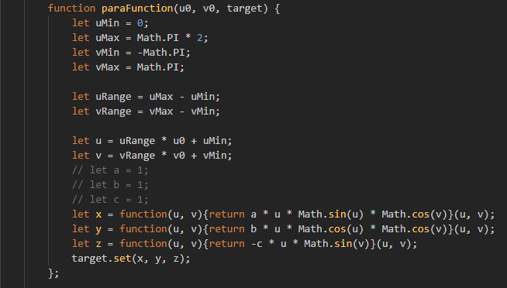

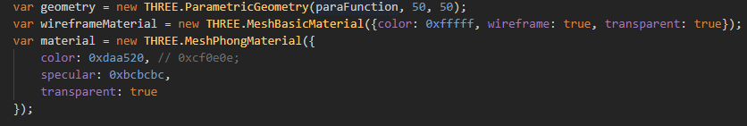

Also, I have added to the scene a light, for better visualization of the surface.

The second part of the requirements was implementing tangent and a normal vector to our surface. For creating it, I created a function “calculateVector”

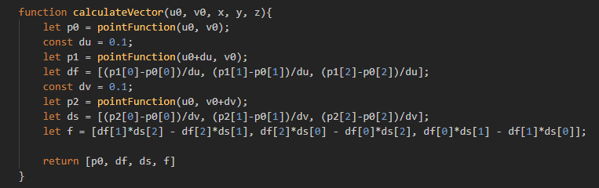

And added it, to the script for rendering on the web page:

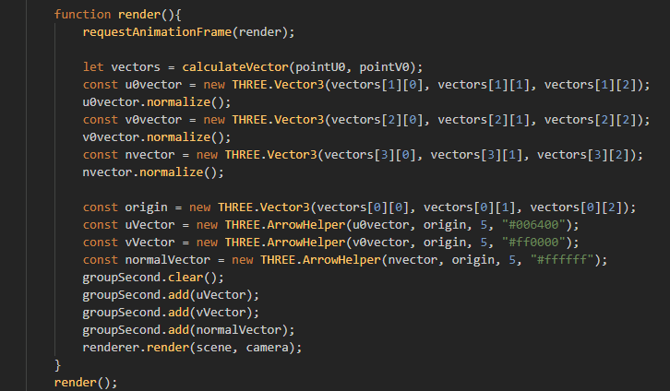

Also, I added a class ArrorHelper from THREEJs library for representing vectors near surface and viewed on the page.

After realization, it looks like this:

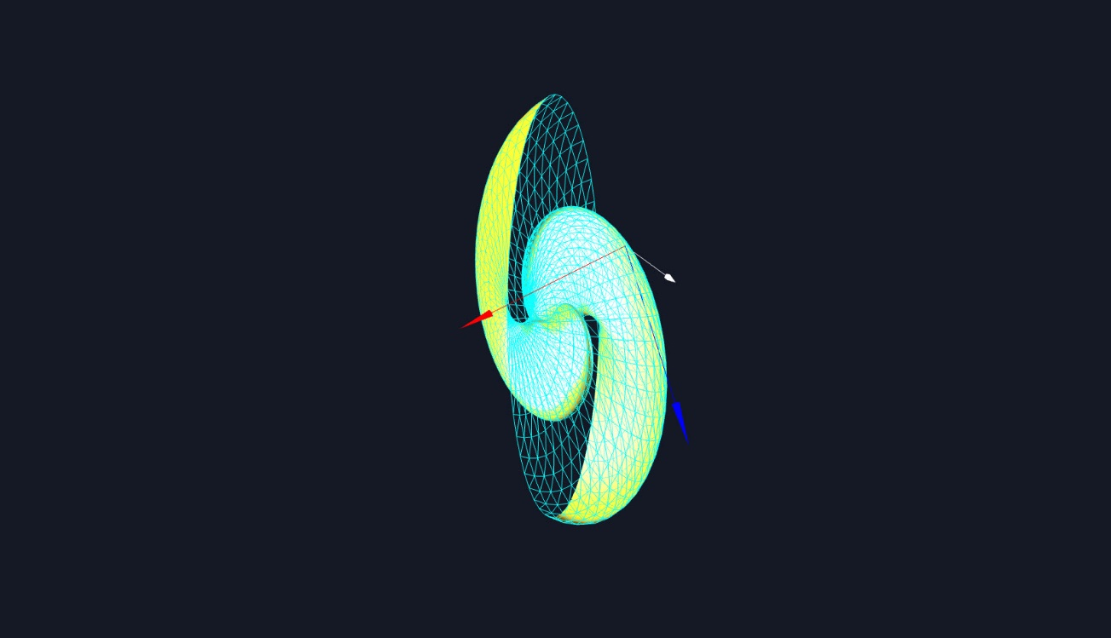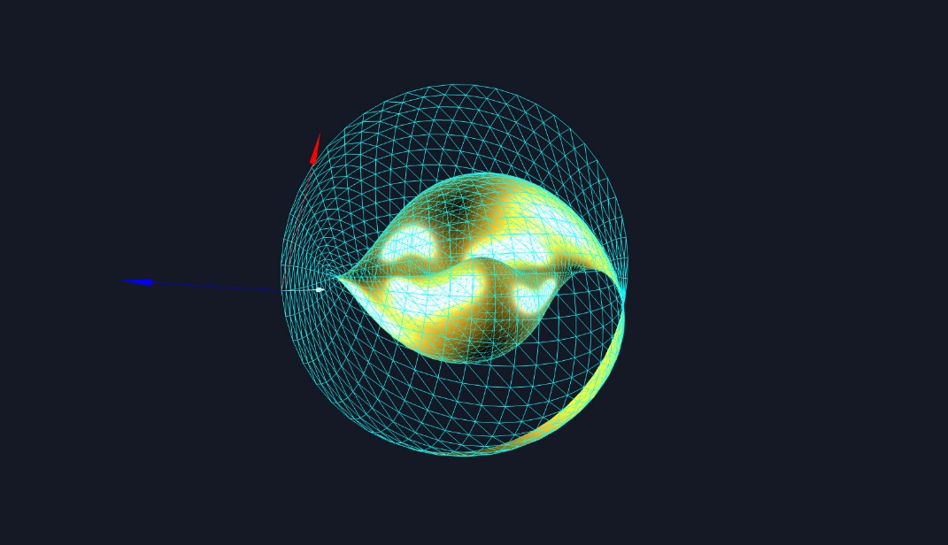

To the page, I have added a possibility to move a point vector. We can move it by keyboard keys.

A – move point to the left side,

D – right,

W – above

And S – down.

Additionally, I added a possibility to see the surface from different side and zoom in-out it. For realization it, I used a class OrbitControls from the library THREEJs.

To view all code implementation of the requirement, I will attach file to my mail.

References:

1. Encyclopedia of Analytical Surfaces - S.N. Krivoshapko, V.N. Ivanov. p.280.
2. https://threejs.org/docs/